**TIME SHEET OF EMPLOYEE**

|  |  |
| --- | --- |
| **CONTENT** | **PAGE NO** |
| **Abstract** |  |
| **1.INTRODUCTION** |  |
| 1.1 Motivation |  |
| 1.2 Problem Statement |  |
| 1.3 Objective of the Project |  |
| 1.4 Scope |  |
| 1.5 Project Introduction |  |
| **2.LTERATURE SURVEY** |  |
| 2.1 Related Work |  |
| **3. SYSTEM ANALYSIS** |  |
| 3.1 Existing System |  |
| 3.2 Disadvantages |  |
| 3.3 Proposed System |  |
| 3.4 Advantages |  |
| 3.5 work Flow of Proposed system |  |
| **4. REQUIREMENT ANALYSIS** |  |
| 4.1Function and non-functional requirements |  |
| 4.2 Hardware Requirements |  |
| 4.3 Software Requirements |  |
| 4.4 Architecture |  |
| **5. SYSTEM DESIGN** |  |
| 5.1 Introduction of Input design |  |
| 5.2 UML Diagram(class, use case, sequence, collaborative, deployment, |  |
| 5.3 Data Flow Diagram |  |
| **6. IMPLEMENTATION AND RESULTS** |  |
| 6.1 Modules |  |
| 6.2 Output Screens |  |
| 1. **JAVA ENVIRONMENT** |  |
| 7.1 Software Installation |  |
| 7.2 About Java Language |  |
| 1. **SYSTEM STUDY AND TESTING** |  |
| 8.1 Feasibility study |  |
| 8.2 Types of test |  |
| **9. CONCLUSION** |  |
| **10. FUTURE ENHANCEMENT** |  |
| **11. REFERENCES** |  |

**ABSTRACT**

A time sheet is an essential tool used by organizations to track and manage employee working hours. It serves as a record of the time spent by employees on different tasks, projects, or activities, facilitating accurate and efficient payroll processing, project management, and resource allocation. This abstract provides an overview of the key aspects and benefits of implementing a time sheet system. The time sheet system enables employees to log their work hours, including start and end times, breaks, and overtime, providing a comprehensive view of their daily or weekly activities. This data serves as a reliable source for calculating wages, ensuring fair compensation for the hours worked. By automating this process, organizations can minimize errors and disputes related to time and attendance, improving transparency and trust between employees and employers. Moreover, time sheets offer valuable insights into resource allocation and project management. By analyzing the recorded data, organizations can assess the time spent on different tasks or projects, identify bottlenecks, and optimize workflows. This information aids in making informed decisions regarding resource allocation, workload balancing, and project timelines, enhancing overall productivity and efficiency. Implementing a digital time sheet system further enhances the benefits. It provides employees with an intuitive and user-friendly interface to record their time, reducing administrative burden and paperwork. Additionally, digital systems often offer features such as real-time tracking, automatic reminders, and reporting capabilities, streamlining the time management process and enabling prompt action when deviations or issues arise.

**Keywords**: Employee, Time, Work, salary , Attendance etc.

1. **INTRODUCTION**

**1.1 Motivation:**

The motivation behind implementing an time sheet of employee is to optimize HR processes, enhance data accuracy, comply with legal requirements, improve employee engagement, and drive organizational success through effective talent management. Streamlining Administrative Tasks: An time sheet of employee can automate and streamline various administrative tasks such as employee data management, attendance tracking, leave management, and payroll processing. By centralizing these functions, the system reduces manual effort, minimizes errors, and improves overall efficiency.

**1.2 Problem Statement:**

Traditional time sheet of employee, often reliant on manual processes and outdated technologies, pose numerous challenges and limitations for organizations. These systems are often characterized by cumbersome paperwork, time-consuming administrative tasks, data inconsistencies, and lack of real-time insights. This statement highlights the problems associated with traditional time sheet of employee and emphasizes the need for a more efficient and streamlined approach

**1.3 Objective of the Project:**

The objective of an time sheet of employee is to streamline and automate various aspects of human resource management, ultimately improving operational efficiency, enhancing employee productivity, and facilitating effective decision-making

**1.4 Scope:**

The scope of an time sheet of employee encompasses various aspects of human resource management within an organization. It includes a wide range of functionalities and modules designed to streamline and automate processes related to employee data management, performance evaluation, attendance tracking, leave management, payroll processing, and more.

**1.5 Project Introduction:**

Introduction to the " Time sheet of employee " Project:

Effective time management is crucial for the smooth functioning of any organization. It involves accurately tracking and managing employee working hours to ensure fair compensation, streamline payroll processes, and optimize resource allocation. A time sheet is a valuable tool that allows organizations to record and monitor the time spent by employees on various tasks, projects, or activities. This introduction provides an overview of the importance and benefits of using a time sheet system.

The primary purpose of a time sheet is to provide a detailed account of the hours worked by employees. It serves as a reliable source of information for calculating wages and ensuring compliance with labor regulations. By accurately documenting work hours, including regular hours, overtime, breaks, and leave, organizations can confidently process payroll, reducing errors and disputes related to employee compensation.

Time sheets also play a crucial role in project management. By tracking the time spent on different tasks or projects, organizations gain insights into resource utilization, productivity levels, and project timelines. This information helps in identifying areas of improvement, optimizing workflows, and making informed decisions regarding resource allocation. It enables managers to allocate resources effectively, avoid bottlenecks, and ensure that projects are completed within deadlines.

Moreover, time sheets promote transparency and accountability within an organization. Employees are required to log their work hours, providing visibility into their activities and ensuring that they are accountable for the time they spend at work. This transparency fosters a culture of trust and fairness, where employees and employers have a clear understanding of the time commitments and expectations.

Implementing a digital time sheet system offers additional benefits over traditional paper-based methods. Digital systems provide a user-friendly interface that simplifies the process of recording time. They often offer features such as automatic reminders, real-time tracking, and reporting capabilities, making it easier for employees to accurately log their hours and for managers to monitor and analyze the data. Digital systems also enable seamless integration with other organizational systems, such as payroll or project management software, streamlining processes and reducing administrative overhead.

1. **LITERATURE SURVEY**

**2.1 Related Work:**

[1] **Smith, J., Johnson, A., Williams, L., "A Systematic Review of Employee Management Systems: Features, Challenges, and Benefits", Journal of Human Resources Management, 2019**

This comprehensive review examines various employee management systems and their features. It explores the challenges faced during implementation and provides insights into the benefits organizations can achieve by adopting such systems. The study also discusses the role of technology in driving effective employee management practices.

**[2] Brown, M., Davis, R., Thompson, S, "The Impact of Employee Management Systems on Organizational Performance" ,International Journal of Business Studies, 2018**

This study investigates the relationship between the implementation of employee management systems and organizational performance. It analyzes data from several organizations and highlights the positive impact of these systems on employee productivity, job satisfaction, and overall organizational effectiveness. The research emphasizes the importance of aligning the system's features with organizational goals for optimal results.

**[3] Chen, H., Li, Q., Wang, Y, "Exploring Employee Self-Service Features in Employee Management Systems", Information Systems Research, 2020**

Focusing on the self-service aspect of employee management systems, this study explores how self-service features influence employee engagement and satisfaction. It discusses the role of self-service portals in empowering employees to manage their own information, request leaves, access training materials, and participate in performance evaluations. The research highlights the positive outcomes of employee self-service functionalities.

**[4] Gupta, R., Sharma, S., Kumar, A, "Implementation Strategies for Employee Management Systems: A Case Study Analysis", Journal of Strategic HR Management, 2021**

This case study analysis examines the implementation strategies employed by organizations while adopting employee management systems. It identifies key factors for successful implementation, including change management, employee training, data migration, and stakeholder engagement. The study provides practical insights and recommendations for organizations planning to implement such systems

**[5] Lee, E., Park, S., Kim, J, "Security and Privacy Considerations in Employee Management Systems", International Journal of Information Security, 2022**

This research paper addresses the critical security and privacy concerns associated with employee management systems. It discusses potential vulnerabilities and threats, along with best practices and security measures to protect sensitive employee data. The study emphasizes the importance of data protection and compliance with privacy regulations to ensure the integrity and confidentiality of employee information.

**[6] Mitchell, L., Turner, K., Parker, S, "The Role of Employee Management Systems in Talent Development and Succession Planning", Journal of Organizational Development, 2019**

Focusing on talent development and succession planning, this study explores how employee management systems support the identification and nurturing of high-potential employees. It discusses the role of performance evaluation, training modules, and career development planning within the system. The research highlights the significance of these systems in building a robust talent pipeline.

**3. SYSTEM ANALYSIS**

**3.1 Existing System**

The existing system for time sheet of employee often relies on manual processes, spreadsheets, and disjointed software solutions. It involves maintaining physical records, manually tracking attendance and leave, conducting performance evaluations using paper-based forms, and manually processing payroll. This traditional approach is time-consuming, error-prone, and lacks efficiency and data accuracy. It also hampers effective decision-making and limits the ability to adapt to changing work dynamics.

* 1. **Disadvantages**

**1.** **Not User Friendly:** The existing system is not user friendly because the retrieval of data is very slow and data is not maintained efficiently.

**2.** **Difficulty in report generating:** We can’t able see the all the tourism places information. And the people not get at the time of searching for tour.

**3.** **Manual control:** people may be get some wrong information from diffrent resources .

**4.** **Time consuming:** Every work is done manually so we cannot get the information in the middle of the tour or as per the requirement because it is very time consuming.

**3.3 Proposed System**

The proposed system is an time sheet of employee, which is a comprehensive software solution designed to automate and streamline time sheet of employee. It integrates various modules and functionalities to centralize employee data, automate attendance tracking, leave management, performance evaluations, and payroll processing. The proposed system aims to provide a user-friendly interface, efficient data management, and real-time access to employee information. It offers features like self-service portals for employees, advanced reporting and analytics capabilities, and compliance management tools. The proposed system improves data accuracy, reduces administrative workload, enhances productivity, and enables organizations to make informed decisions based on actionable insights. It also supports remote work arrangements, provides mobile access, and offers scalability and adaptability to meet evolving HR requirements.

**3.4 Advantages**

**1.** **User Friendly:** - The proposed system is user friendly because the retrieval and storing of data is fast and data is maintained efficiently. Moreover the graphical user interface is provided in the proposed system, which provides user to deal with the system very easily.

**2.** **Reports are easily generated:** reports can be easily generated in the proposed system so user can get information at anytime

**3. Very less work:** The proposed system requires very less work. All the data is fetched into the computer immediately and reports can be generated through computers. Moreover work becomes very easy because there is no need to keep data on papers.

**4. Computer operator control:** Computer operator control will be there so no chance of errors. Moreover storing and retrieving of information is easy. So work can be done speedily and in time.

**3.5 work Flow of Proposed system**

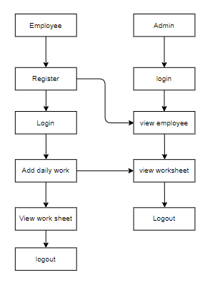

**4. REQUIREMENT ANALYSIS**

**4.1 Functional and non-functional requirements**

Requirement’s analysis is very critical process that enables the success of a system or software project to be assessed. Requirements are generally split into two types: Functional and non-functional requirements.

**Functional Requirements**: These are the requirements that the end user specifically demands as basic facilities that the system should offer. All these functionalities need to be necessarily incorporated into the system as a part of the contract. These are represented or stated in the form of input to be given to the system, the operation performed and the output expected. They are basically the requirements stated by the user which one can see directly in the final product, unlike the non-functional requirements.

Examples of functional requirements:

1. Authentication of user whenever he/she logs into the system
2. System shutdown in case of a cyber-attack
3. A verification email is sent to user whenever he/she register for the first time on some software system.

**Non-functional requirements**: These are basically the quality constraints that the system must satisfy according to the project contract. The priority or extent to which these factors are implemented varies from one project to other. They are also called non-behavioral requirements.  
They basically deal with issues like:

* Portability
* Security
* Maintainability
* Reliability
* Scalability
* Performance
* Reusability
* Flexibility

Examples of non-functional requirements:

1. Emails should be sent with a latency of no greater than 12 hours from such an activity.
2. The processing of each request should be done within 10 seconds
3. The site should load in 3 seconds whenever of simultaneous users are > 10000
   1. **Hardware Requirements**

# Processor : - I3/Intel Processor

# Operating System : Windows 7/8/10

# Server side Script : HTML,CSS,JS

# Programming Language : java

# IDE/Workbench : Intellij IDEA

* 1. **Software Requirements:**

Technology : java

Server Deployment : tomcat Server

Database : MySQL

**Architecture:**

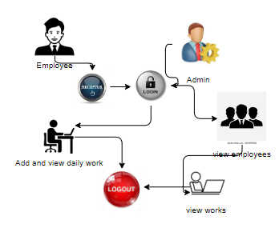

**5. SYSTEM DESIGN**

**5.1 Introduction of Input Design:**

In an information system, input is the raw data that is processed to produce output. During the input design, the developers must consider the input devices such as PC, MICR, OMR, etc.

Therefore, the quality of system input determines the quality of system output. Well-designed input forms and screens have following properties −

* It should serve specific purpose effectively such as storing, recording, and retrieving the information.
* It ensures proper completion with accuracy.
* It should be easy to fill and straightforward.
* It should focus on user’s attention, consistency, and simplicity.
* All these objectives are obtained using the knowledge of basic design principles regarding −
  + What are the inputs needed for the system?
  + How end users respond to different elements of forms and screens.

### **Objectives for Input Design:**

The objectives of input design are −

* To design data entry and input procedures
* To reduce input volume
* To design source documents for data capture or devise other data capture methods
* To design input data records, data entry screens, user interface screens, etc.
* To use validation checks and develop effective input controls.

**Output Design:**

The design of output is the most important task of any system. During output design, developers identify the type of outputs needed, and consider the necessary output controls and prototype report layouts.

### Objectives of Output Design:

The objectives of input design are:

* To develop output design that serves the intended purpose and eliminates the production of unwanted output.
* To develop the output design that meets the end user’s requirements.
* To deliver the appropriate quantity of output.
* To form the output in appropriate format and direct it to the right person.
* To make the output available on time for making good decisions.

**5.2 UML Diagrams:**

**5.2.1 Use Case Diagram:**

A use case diagram in the Unified Modeling Language (UML) is a type of behavioral diagram defined by and created from a Use-case analysis. Its purpose is to present a graphical overview of the functionality provided by a system in terms of actors, their goals (represented as use cases), and any dependencies between those use cases. The main purpose of a use case diagram is to show what system functions are performed for which actor. Roles of the actors in the system can depicted.

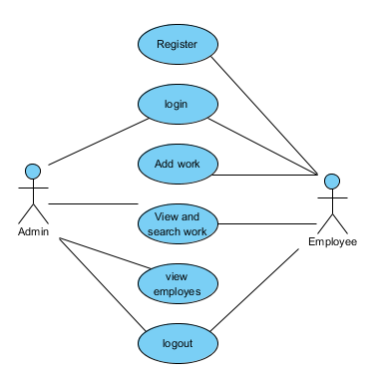

**5.2.2 Class Diagram:**

In software engineering, a class diagram in the Unified Modelling Language (UML) is a type of static structure diagram that describes the structure of a system by showing the system's classes, their attributes, operations (or methods), and the relationships among the classes. It explains which class contains information.

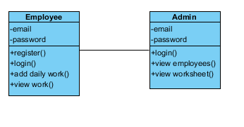

**5.2.3 Sequence Diagram:**

A sequence diagram in Unified Modelling Language (UML) is a kind of interaction diagram that shows how processes operate with one another and in what order. It is a construct of a Message sequence Chart. Sequence diagrams are sometimes called event diagrams, event scenarios, and

Event timings.

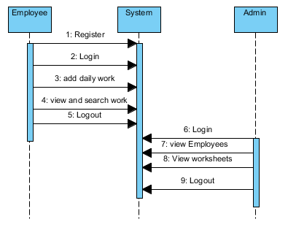

.

**5.2.4 Collaboration Diagram:**

In collaboration diagram the method call sequence is indicated by some numbering technique as shown below. The number indicates how the methods are called one after another. We have taken the same order management system to describe the collaboration diagram. The method calls are similar to that of a sequence diagram. But the difference is that the sequence diagram does not describe the object organization whereas the collaboration diagram shows the object organization.

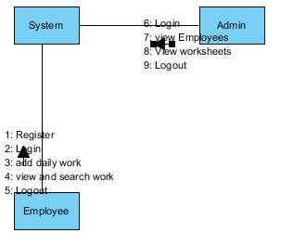

**5.2.5 Deployment Diagram**

Deployment diagram represents the deployment view of a system. It is related to the component diagram. Because the components are deployed using the deployment diagrams. A deployment diagram consists of nodes. Nodes are nothing but physical hardware’s used to deploy the application.

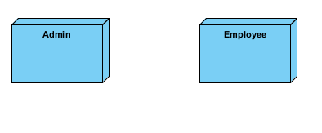

**5.2.6 Activity Diagram:**

Activity diagrams are graphical representations of workflows of stepwise activities and actions with support for choice, iteration and concurrency. In the Unified Modelling Language, activity diagrams can be used to describe the business and operational step-by-step workflows of components in a system. An activity diagram shows the overall flow of control.

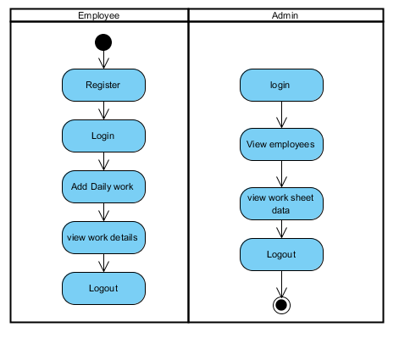

**5.2.7 Component Diagram**:

A component diagram, also known as a UML component diagram, describes the organization and wiring of the physical **c**omponents in a system. Component diagrams are often drawn to help model implementation details and double-check that every aspect of the system's required functions is covered by planned development.

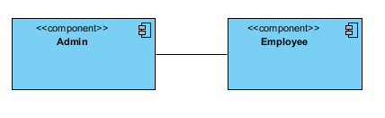

**5.2.8 ER Diagram:**

An Entity–relationship model (ER model) describes the structure of a database with the help of a diagram, which is known as Entity Relationship Diagram (ER Diagram). An ER model is a design or blueprint of a database that can later be implemented as a database. The main components of E-R model are: entity set and relationship set.

An ER diagram shows the relationship among entity sets. An entity set is a group of similar entities and these entities can have attributes. In terms of DBMS, an entity is a table or attribute of a table in database, so by showing relationship among tables and their attributes, ER diagram shows the complete logical structure of a database. Let’s have a look at a simple ER diagram to understand this concept.

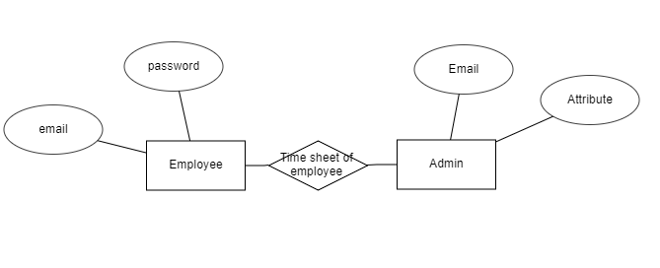

**5.3 DFD Diagram:**

A Data Flow Diagram (DFD) is a traditional way to visualize the information flows within a system. A neat and clear DFD can depict a good amount of the system requirements graphically. It can be manual, automated, or a combination of both. It shows how information enters and leaves the system, what changes the information and where information is stored. The purpose of a DFD is to show the scope and boundaries of a system as a whole. It may be used as a communications tool between a systems analyst and any person who plays a part in the system that acts as the starting point for redesigning a system.

**Context level:**

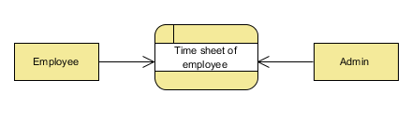

**Level 1 Diagram:**

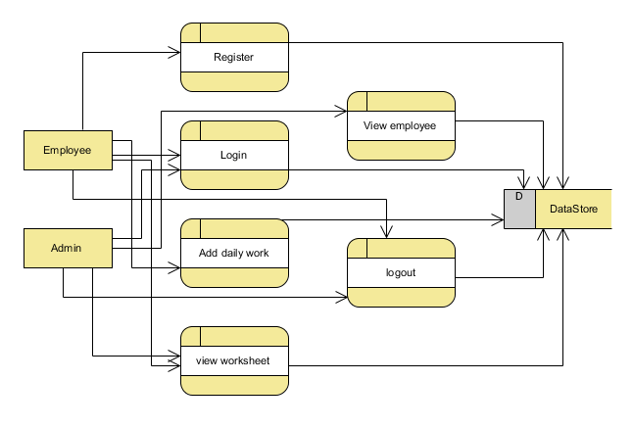

**Level 2 Diagram:**

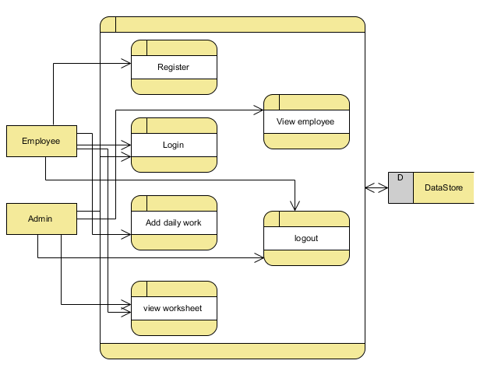

**IMPLEMENTATION AND RESULTS**

**6.1 Modules:**

**Admin:**

Operation-**Login:** Admin will login into the application by entering the valid details like (username and password).

Operation-**view Employee**

**View and search Employee:** Admin can view and search the employee details

**Employee:**

Operation-**Register:** Employee will register into the application by entering the valid details like (username and password etc).

Operation-**Login:** Employee will login into the application by entering the valid details like (username and password).

Operation-**add and view work details**

**Add work:** Employee can add his work details.

**View work:** Employee can view his details.

**6.2 Results:**

Home Page: This is the home page of time sheet project

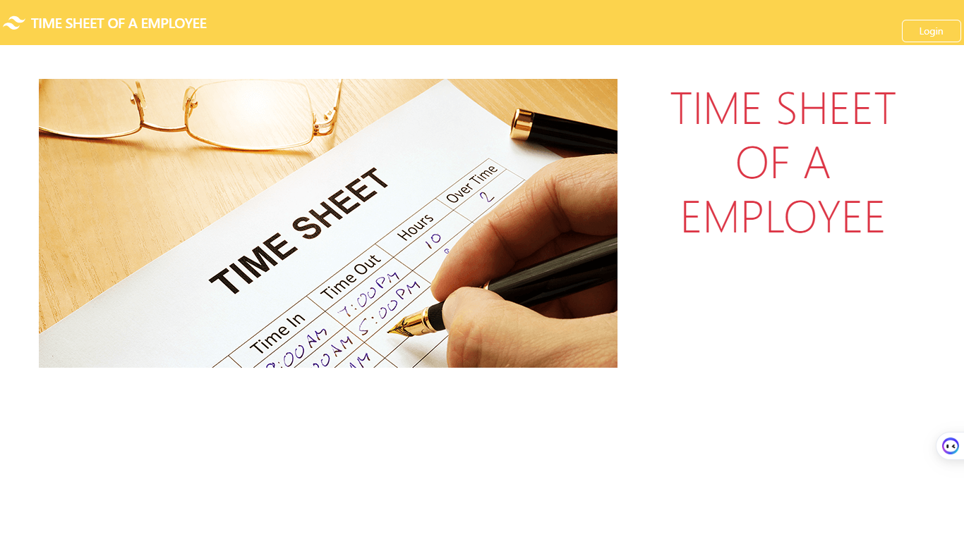

Register Page: This is the registration page for employee

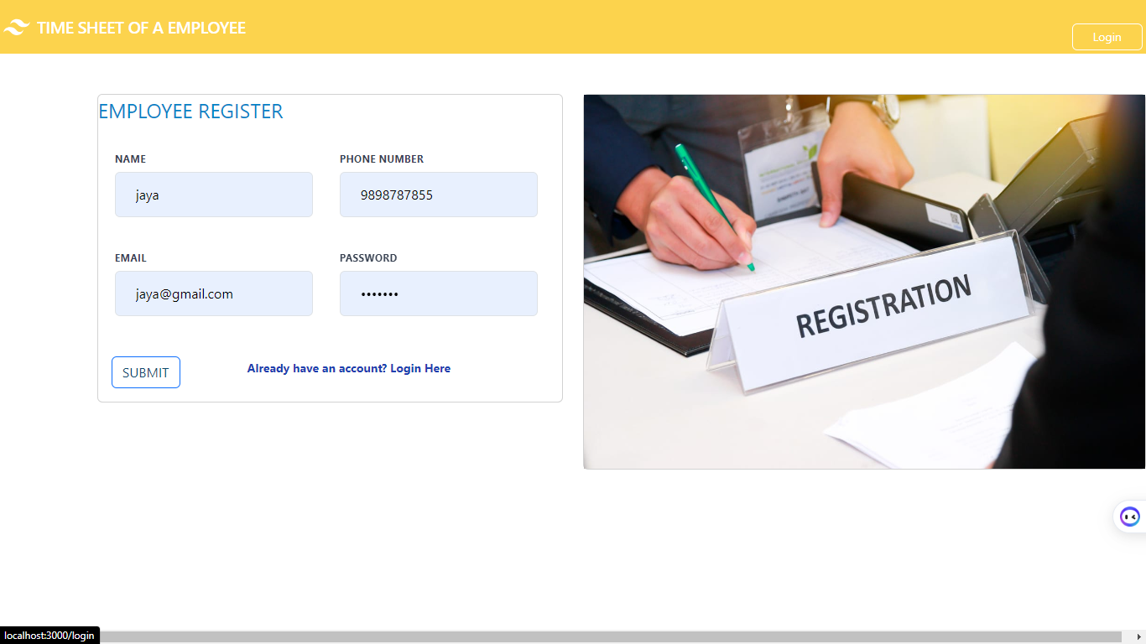

Login Page: This is the login page for both employee and admin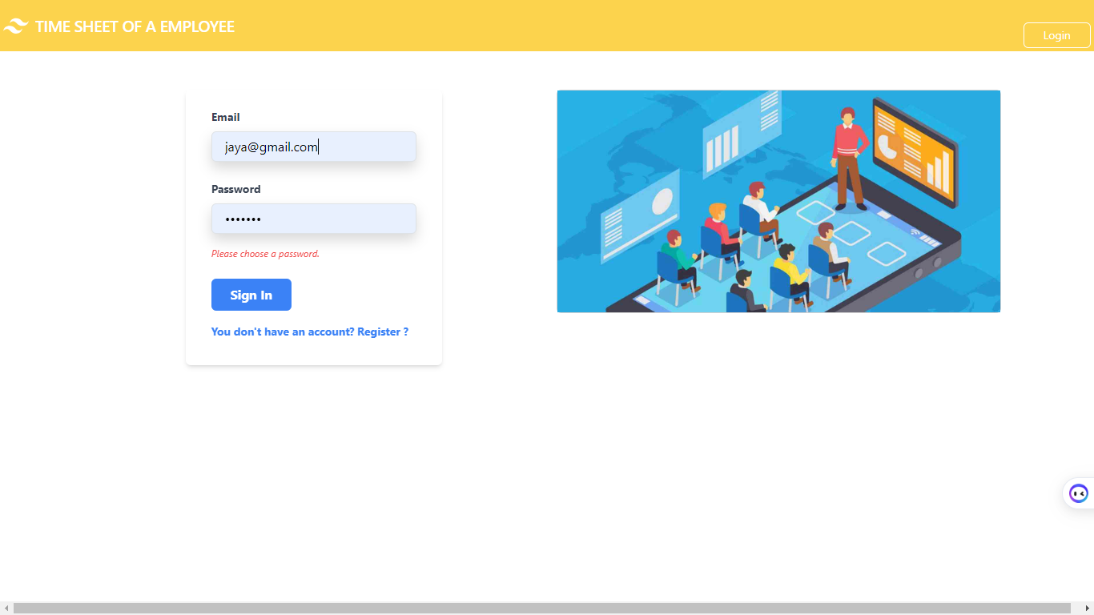

Employee Home :This is the home page for employee

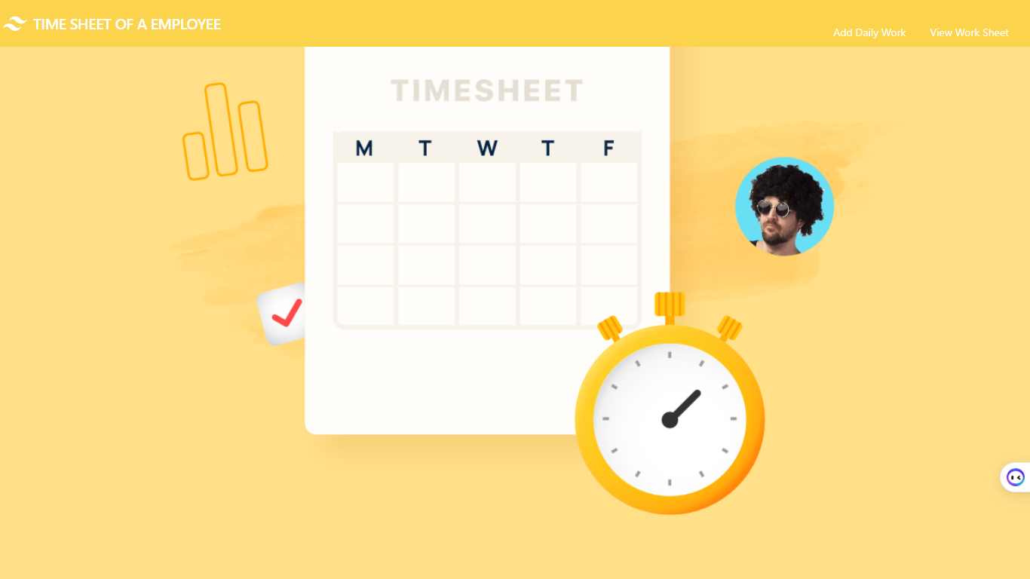

Add Work: Employee Can add their work

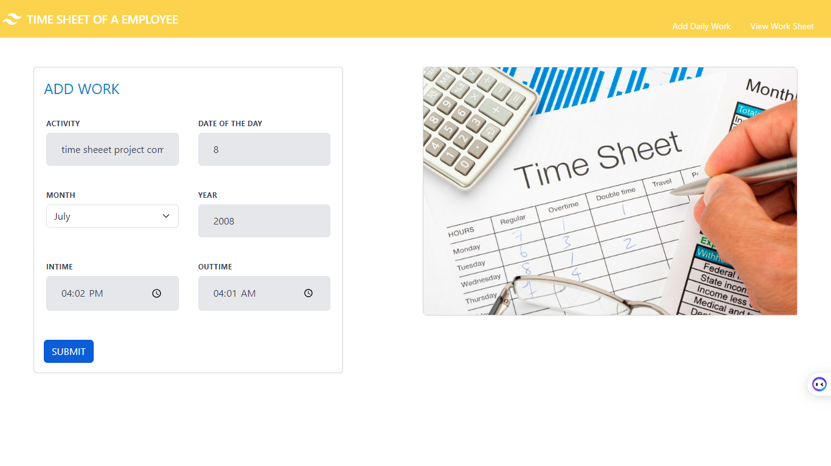

View Work Sheet: Employee can view their work sheet

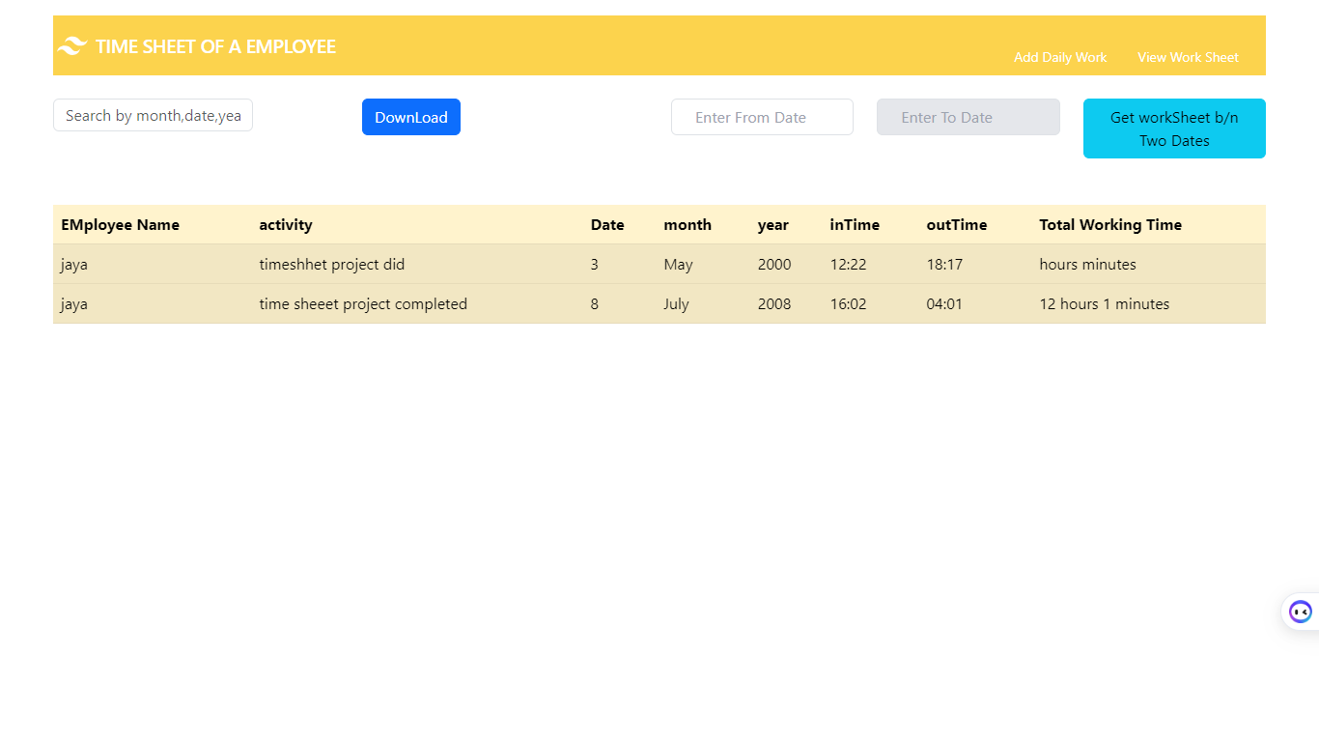

Search By Month: Search a particular month in the worksheet

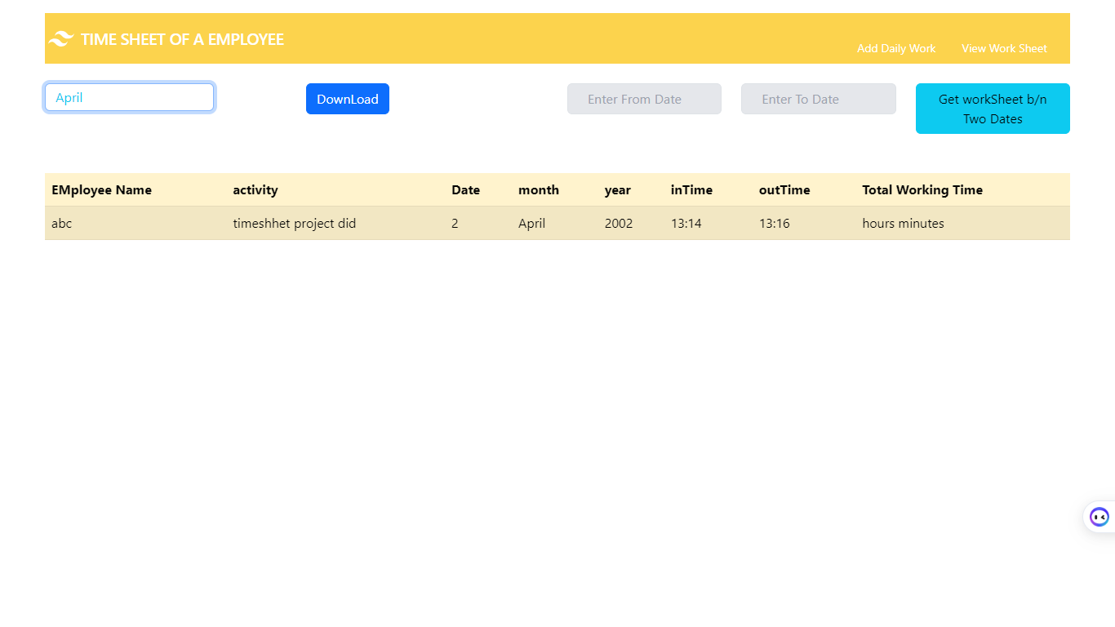

Search By Date: Get the worksheet by searching the date

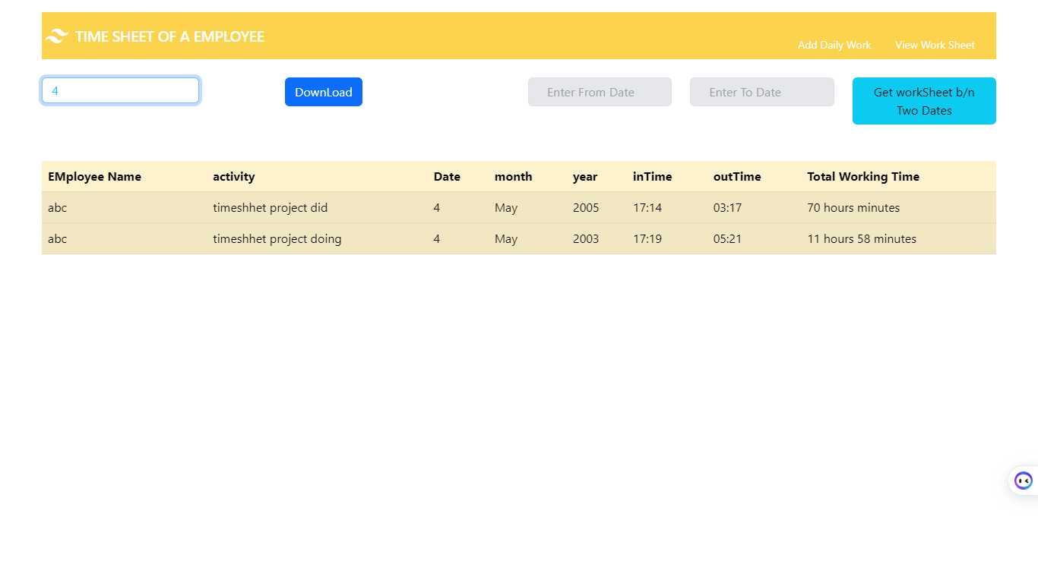

Search By Year: Search the work sheet by particular year

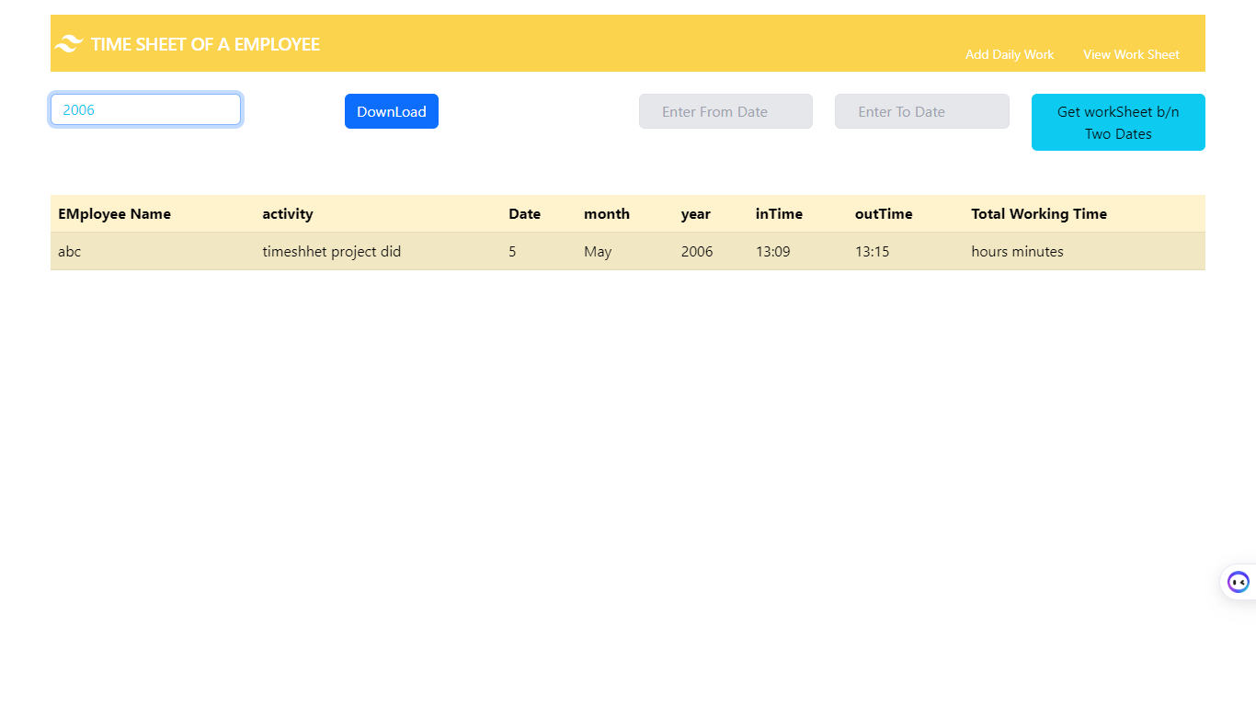  
Get work sheet between from date and To date

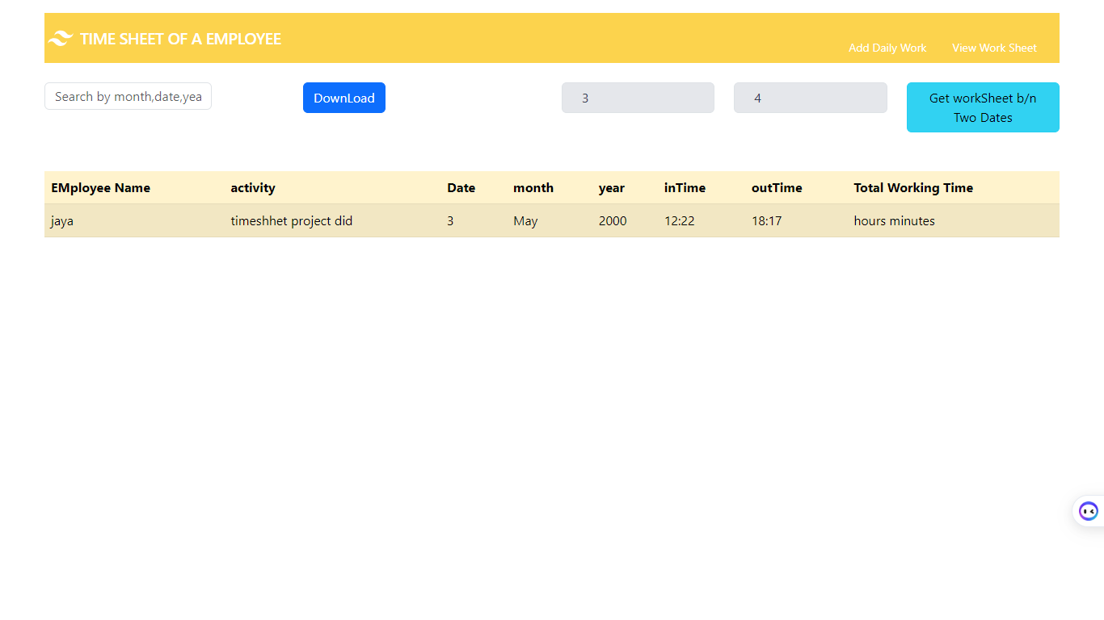

Download: Down load worksheet

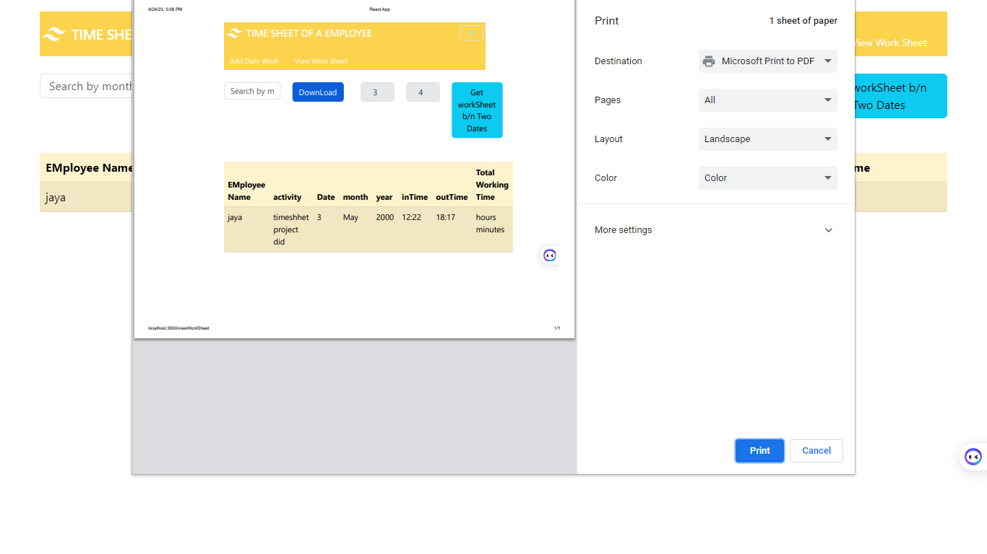Admin Login: Admin can login with the default credentials

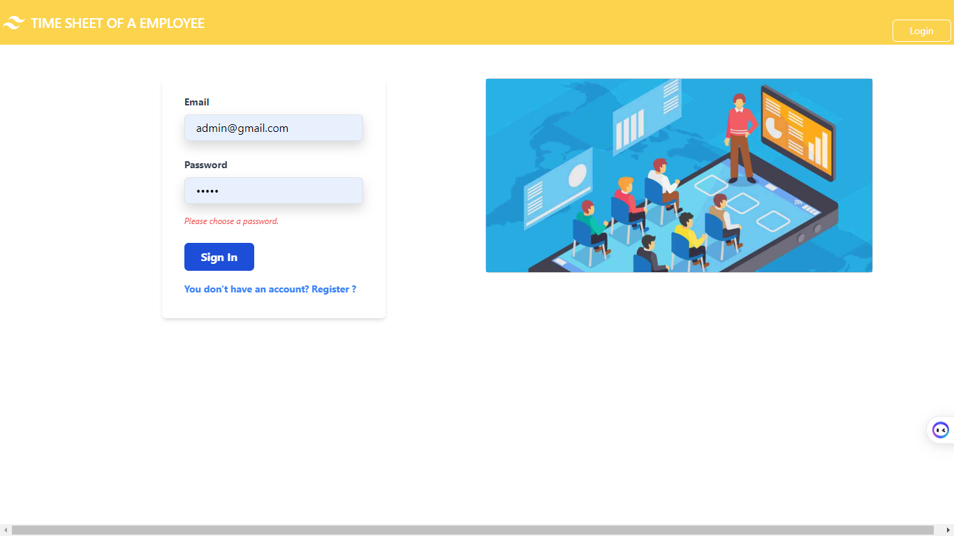

Admin Home: This is the admin Home page

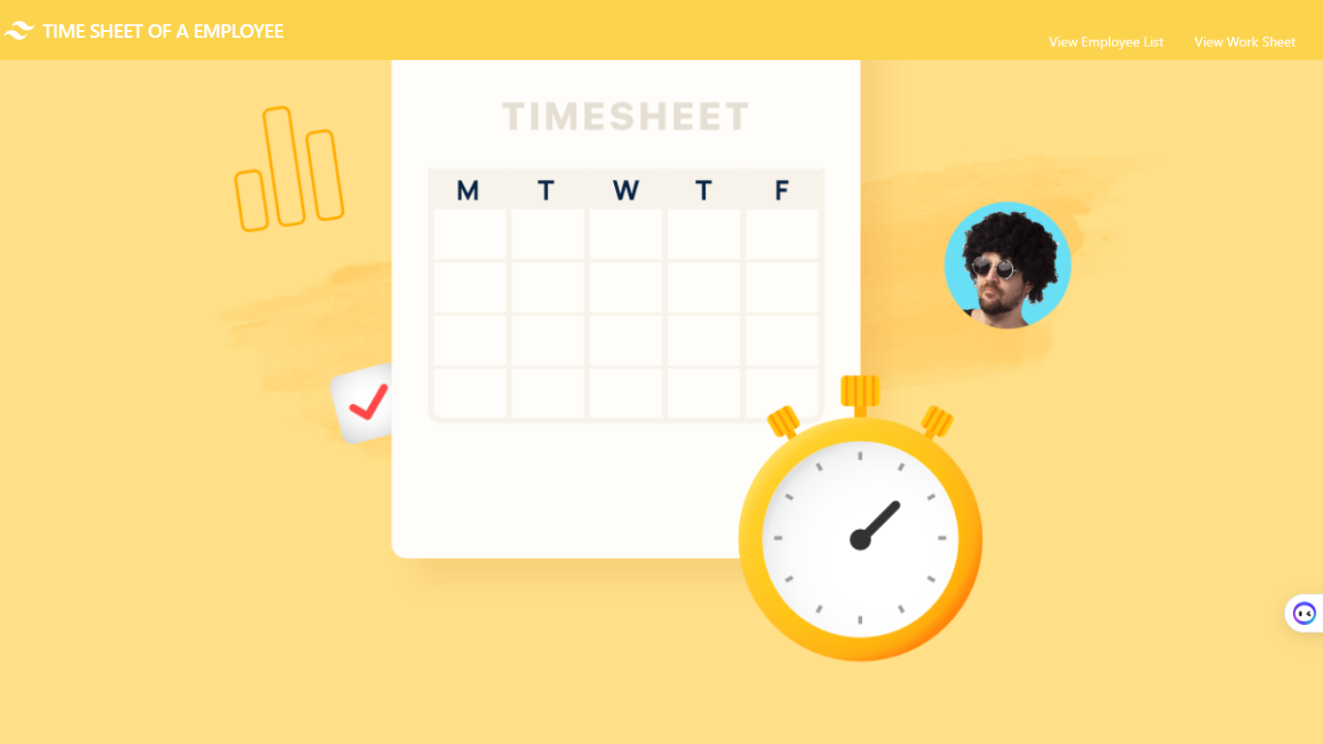View Employee List: View All the employees who registered

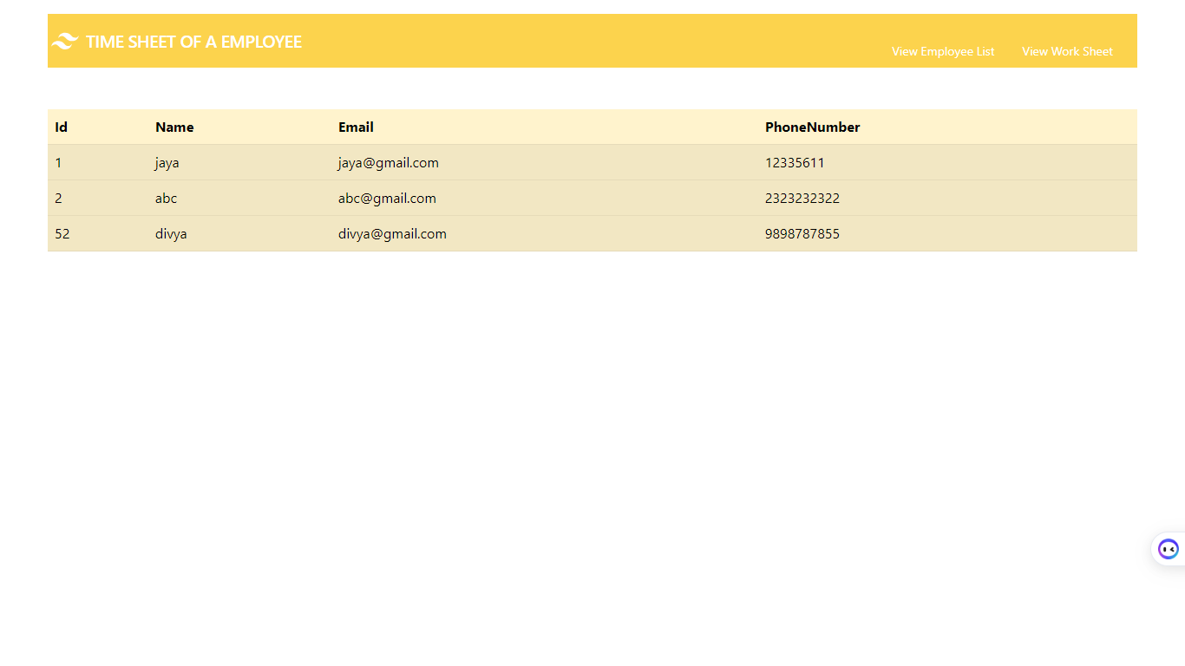

View Total work sheet: Admin can view the work sheet of every employee

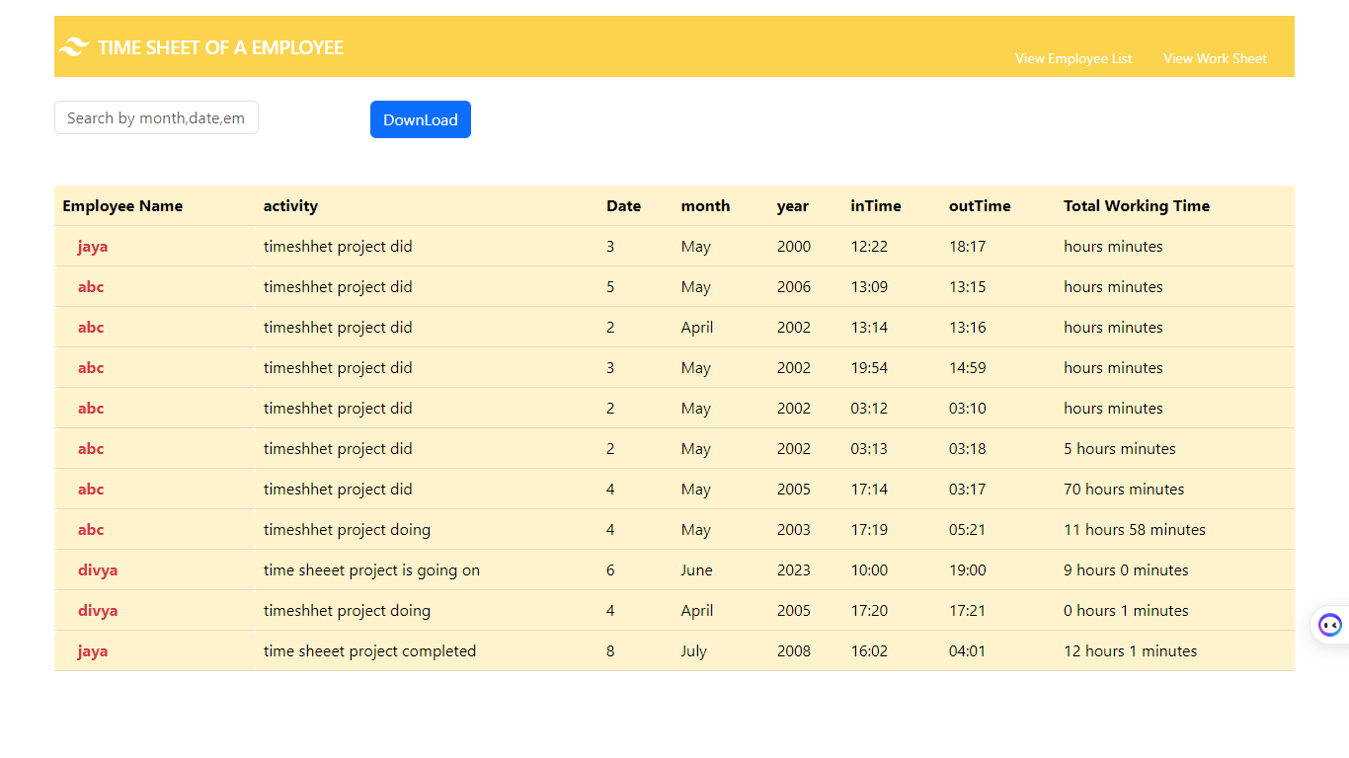

Search By employee Name:

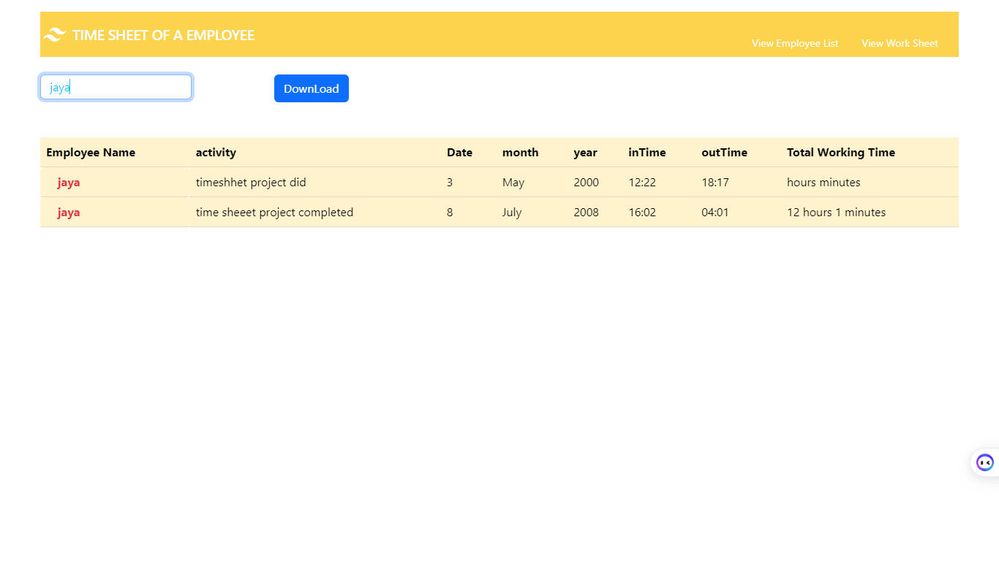

Search By Month:

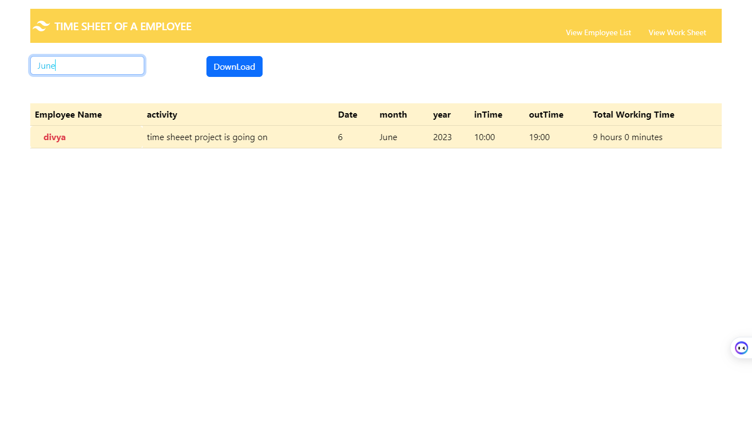Search By Year:

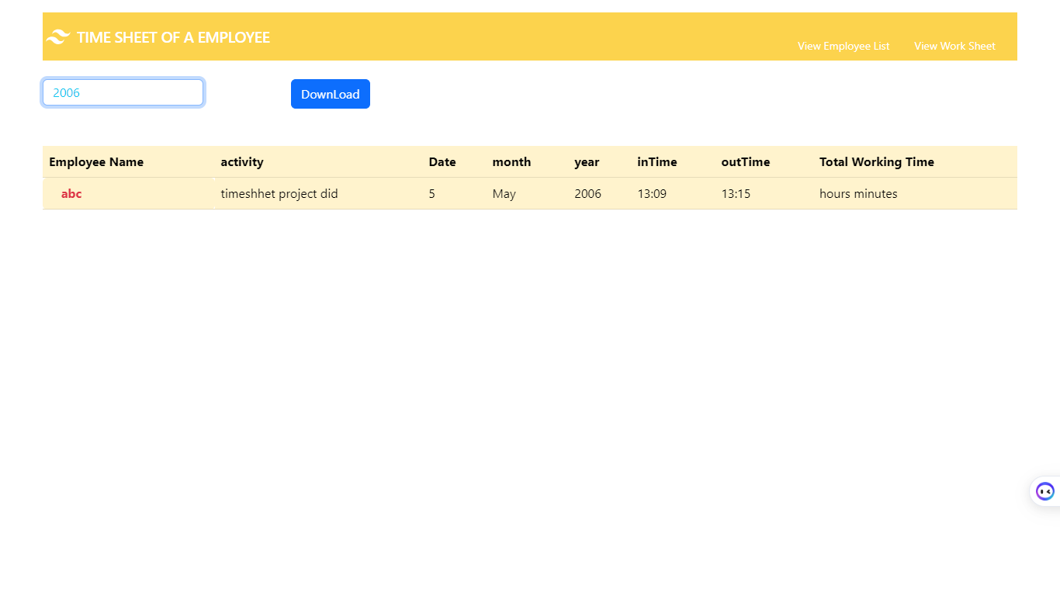

Search BY Date:

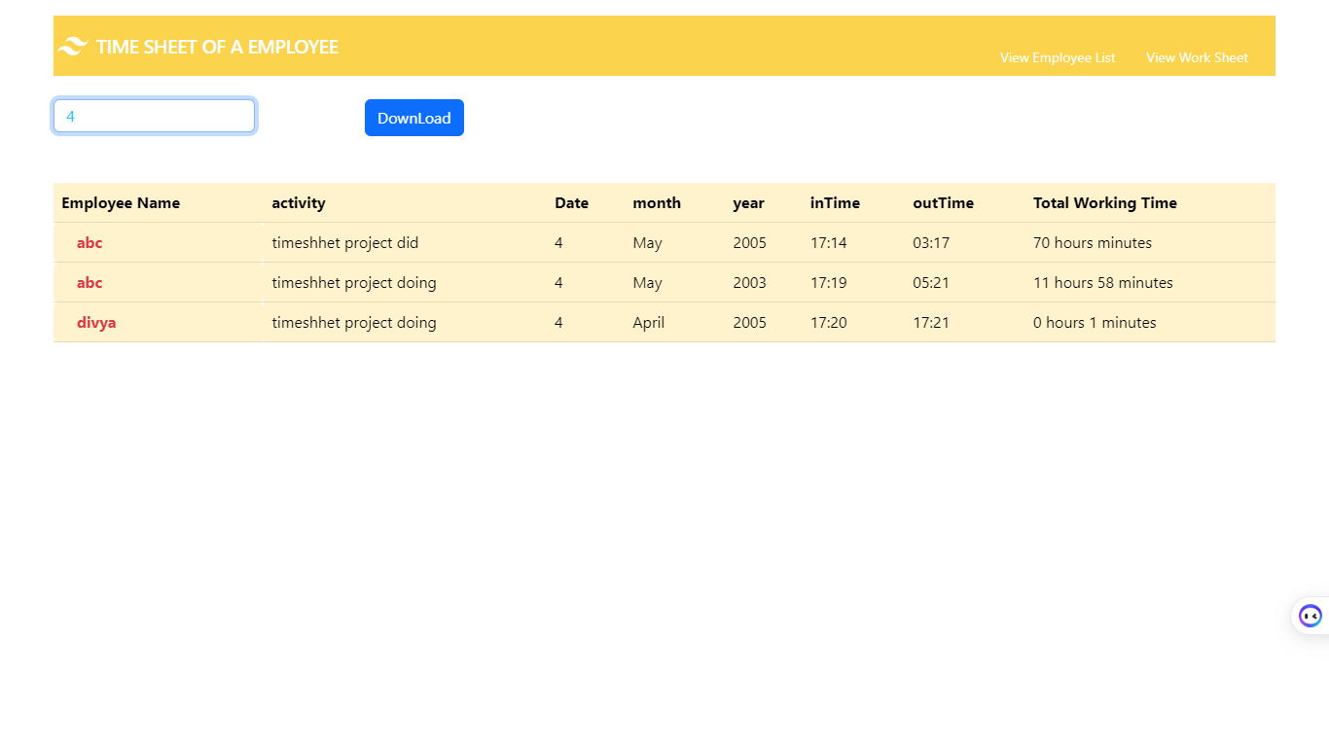

Download Work sheet: 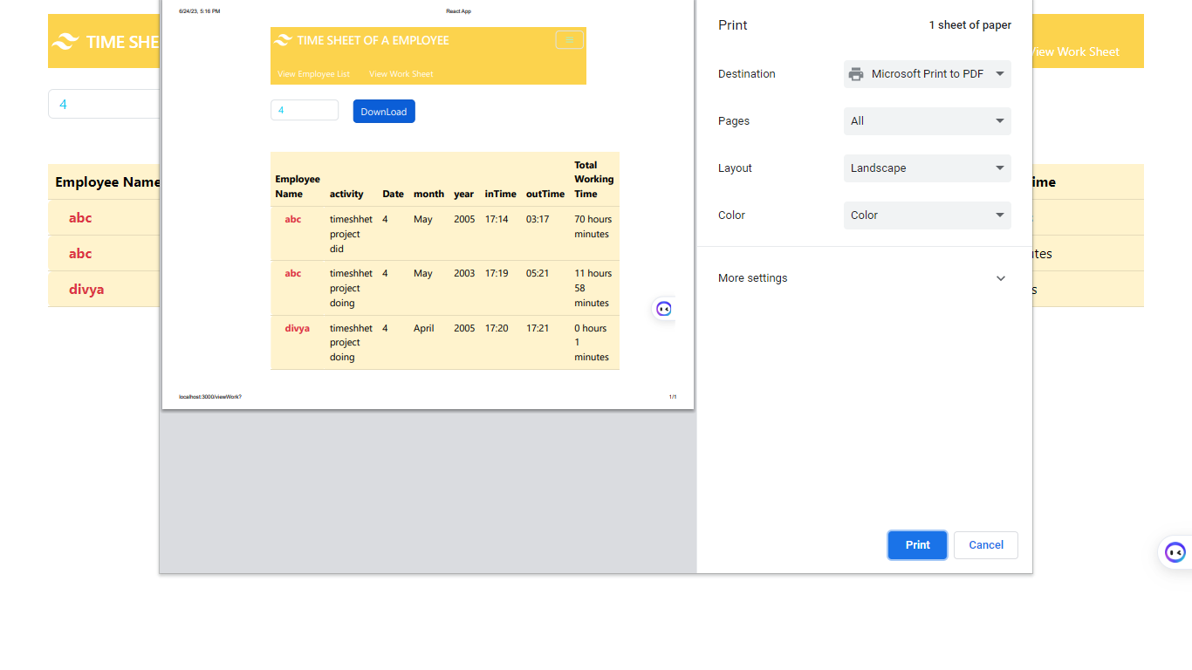

**SOFTWARE INSTALLATION FOR JAVA PROJECTS**

This Java Development Kit(JDK) allows you to code and run Java programs. It's possible that you install multiple JDK versions on the same PC. But It’s recommended that you install only latest version.

## How to install Java for Windows

Following are the steps for JDK 8 free download for 32 bit or JDK 8 download 64 bit and installation

**Step 1)** Go to [link](https://www.oracle.com/java/technologies/javase-downloads.html). Click on JDK Download for Java

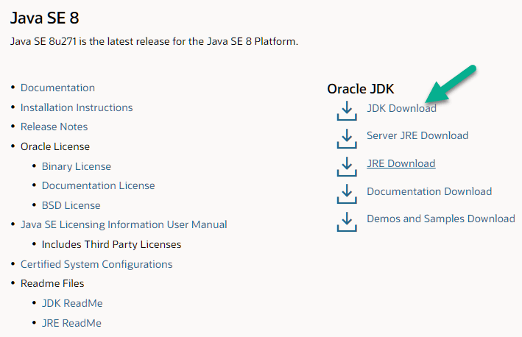

**Step 2)** Next,

1. Accept License Agreement
2. Download Java 8 JDK for your version 32 bit or JDK 8 download for windows 10 64 bit.

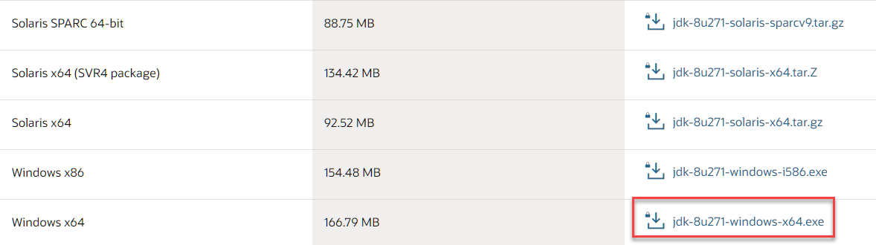

**Step 3)** when you click on the Installation link the popup will be open. Click on I reviewed and accept the Oracle Technology Network License Agreement for Oracle Java SE and you will be redirected to the login page. If you don't have an oracle account you can easily sign up by adding basics details of yours.

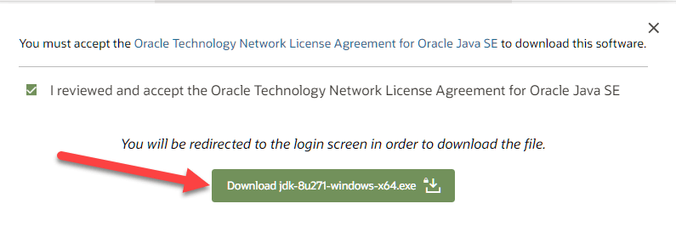

**Step 4)** Once the Java JDK 8 download is complete, run the exe for install JDK. Click Next

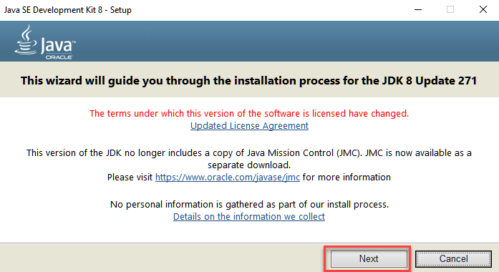

**Step 5)** Select the PATH to install Java in Windows and click next.

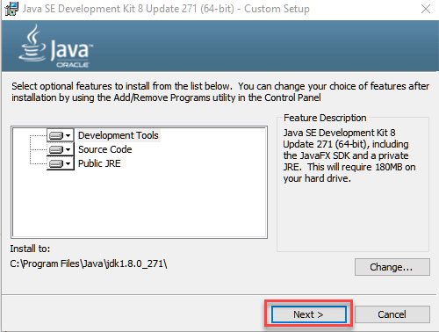

**Step 6)** Once you install Java in windows, click close

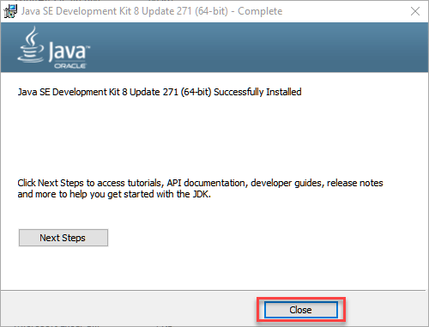

## How to set Environment Variables in Java: Path and Class path

The PATH variable gives the location of executable like javac, java etc. It is possible to run a program without specifying the PATH but you will need to give full path of executable like **C:\Program Files\Java\jdk-13.0.1\bin\javac A.java** instead of simple **javac A.java**

The CLASSPATH variable gives location of the Library Files.

Let's look into the steps to set the PATH and CLASSPATH

**Step 1)** Right Click on the My Computer and Select the properties

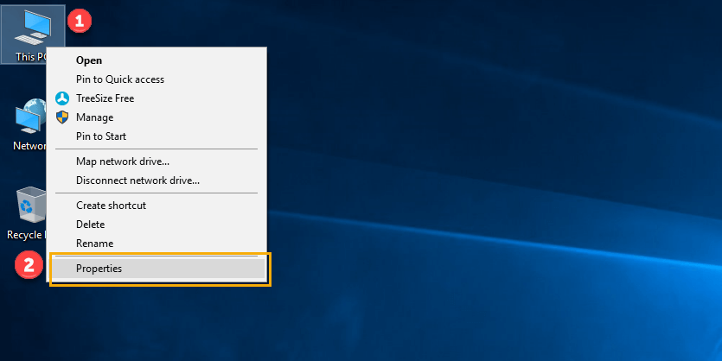

**Step 2)** Click on advanced system settings

**Step 3)** Click on Environment Variables

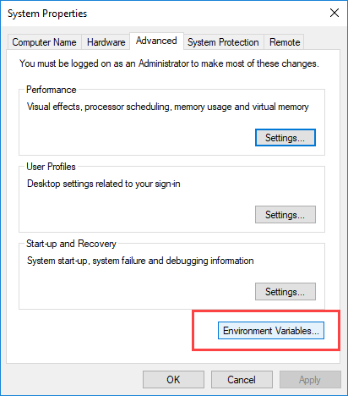

**Step 4)** Click on new Button of User variables

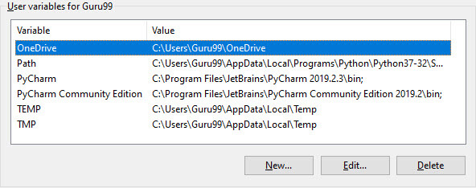

**Step 5)** Type PATH in the Variable name.

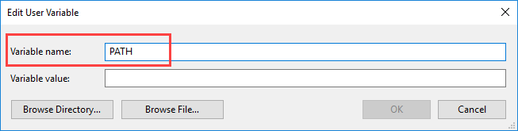

**Step 6)** Copy the path of bin folder which is installed in JDK folder.

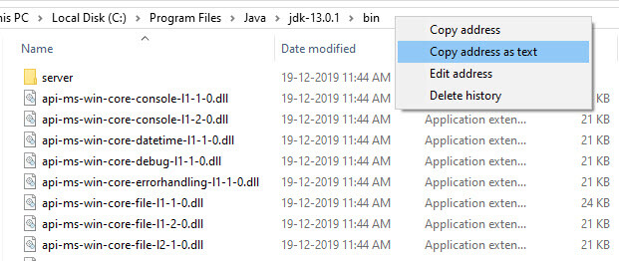

**Step 7)** Paste Path of bin folder in Variable value and click on OK Button.

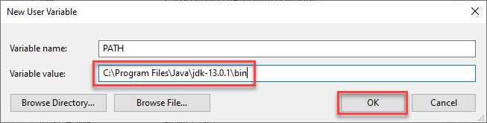

**Note:** In case you already have a PATH variable created in your PC, edit the PATH variable to

PATH = <JDK installation directory>\bin;%PATH%;

Here, %PATH% appends the existing path variable to our new value

**Step 8)**You can follow a similar process to set CLASSPATH.

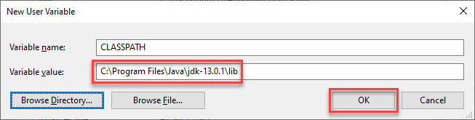

**Note:** In case you java installation does not work after installation, change classpath to

CLASSPATH = <JDK installation directory>\lib\tools.jar;

**Step 9)** Click on OK button

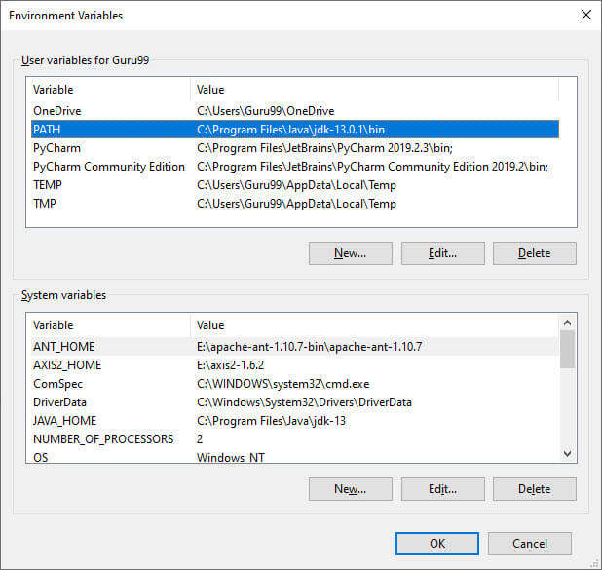

**Step 10)** Go to command prompt and type javac commands.

If you see a screen like below, Java is installed.

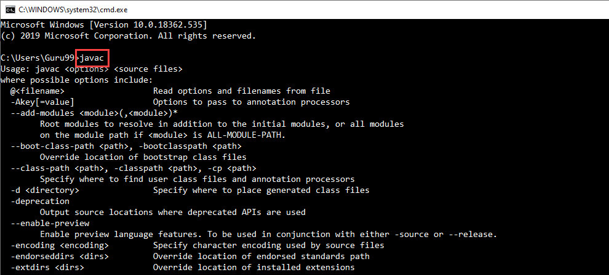

**INSTALLING JAVA AND INTELLIJ IDEA**

**Installing java:**

This Java Development Kit(JDK) allows you to code and run Java programs. It's possible that you install multiple JDK versions on the same PC. But It’s recommended that you install only latest version.

## How to install Java for Windows

Following are the steps for JDK 8 free download for 32 bit or JDK 8 download 64 bit and installation

**Step 1)** Go to [link](https://www.oracle.com/java/technologies/javase-downloads.html). Click on JDK Download for Java



**Step 2)** Next,

1. Accept License Agreement
2. Download Java 8 JDK for your version 32 bit or JDK 8 download for windows 10 64 bit.



**Step 3)** when you click on the Installation link the popup will be open. Click on I reviewed and accept the Oracle Technology Network License Agreement for Oracle Java SE and you will be redirected to the login page. If you don't have an oracle account you can easily sign up by adding basics details of yours.



**Step 4)** once the Java JDK 8 download is complete, run the exe for install JDK. Click Next



**Step 5)** Select the PATH to install Java in Windows and click next.



**Step 6)** Once you install Java in windows, click close



## How to set Environment Variables in Java: Path and Class path

The PATH variable gives the location of executable like javac, java etc. It is possible to run a program without specifying the PATH but you will need to give full path of executable like **C:\Program Files\Java\jdk-13.0.1\bin\javac A.java** instead of simple **javac A.java**

The CLASSPATH variable gives location of the Library Files.

Let's look into the steps to set the PATH and CLASSPATH

**Step 1)** Right Click on the My Computer and Select the properties



**Step 2)** Click on advanced system settings

**Step 3)** Click on Environment Variables



**Step 4)** Click on new Button of User variables



**Step 5)** Type PATH in the Variable name.



**Step 6)** Copy the path of bin folder which is installed in JDK folder.



**Step 7)** Paste Path of bin folder in Variable value and click on OK Button.



**Note:** In case you already have a PATH variable created in your PC, edit the PATH variable to

PATH = <JDK installation directory>\bin;%PATH%;

Here, %PATH% appends the existing path variable to our new value

**Step 8)**You can follow a similar process to set CLASSPATH.



**Note:** In case you java installation does not work after installation, change classpath to

CLASSPATH = <JDK installation directory>\lib\tools.jar;

**Step 9)** Click on OK button



**Step 10)** Go to command prompt and type javas commands.

If you see a screen like below, Java is installed.



Installing intellij idea:

1. To download Intellij visit the website https://www.jetbrains.com/idea/download/#section=windows and Click the "DOWNLOAD" link under the Community Section.

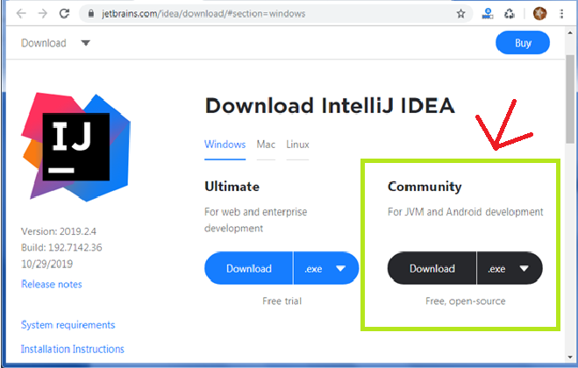

1. Once the download is complete, run the exe for install Intellij. The setup wizard should have started. Click “Next”.
2. On the next screen, Change the installation path if required. Click “Next”.
3. On the next screen, you can create a desktop shortcut if you want and click on “Next”.
4. Choose the start menu folder. Keep selected Jet Brains and click on “Install”.
5. Wait for the installation to finish.
6. Once installation finished, you should receive a message screen that Intellij is installed. If you want to go ahead and run it, click the “Run Intellij Community Edition” box first and click “Finish”.
7. After you click on "Finish," the Following screen will appear.

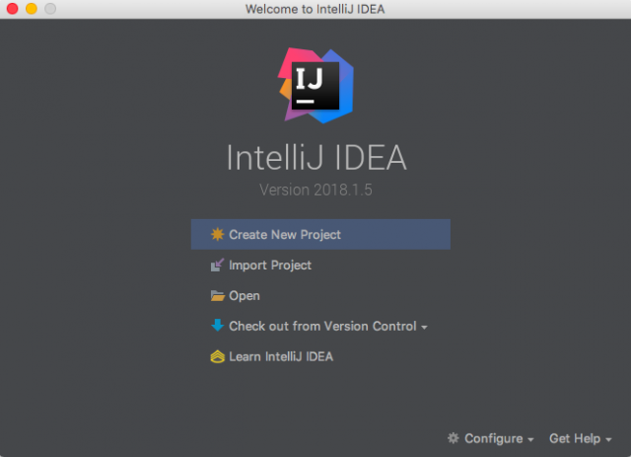

**Installing visual studio code**

Steps to installing visual studio code:

Step 1: Head over to the website <https://code.visualstudio.com/download>

Step2:choose the option as per your choice.

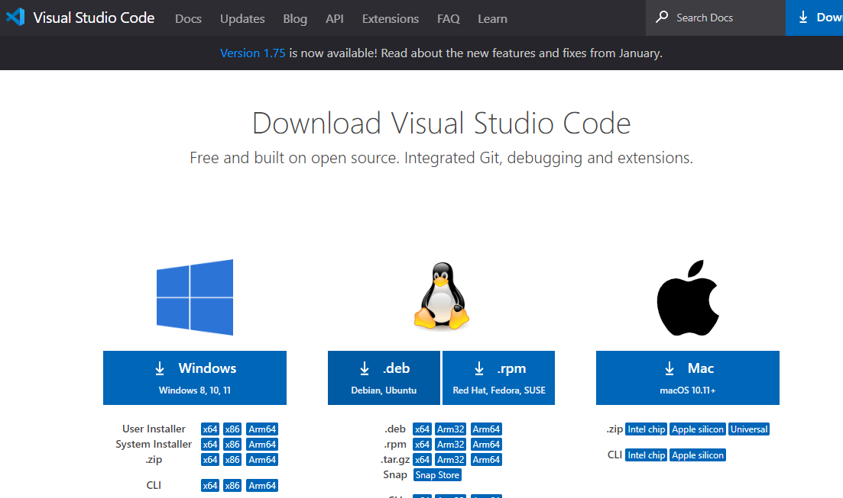

Step 3: Once download completed,open it and your screen will appear like this

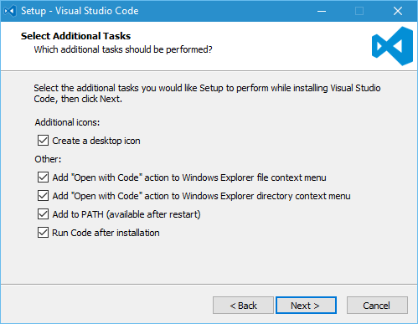

Step 4: click next until you saw the below page

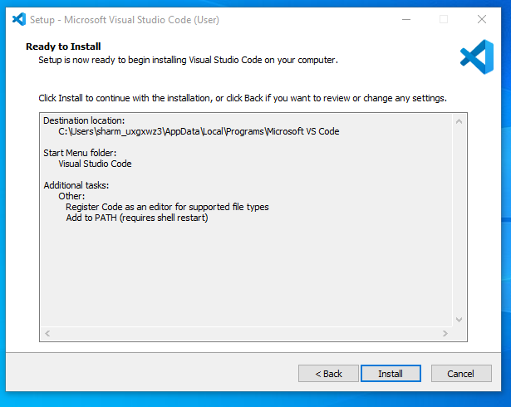

Step 4: After installation your screen will appear like this ,click finish and continue.

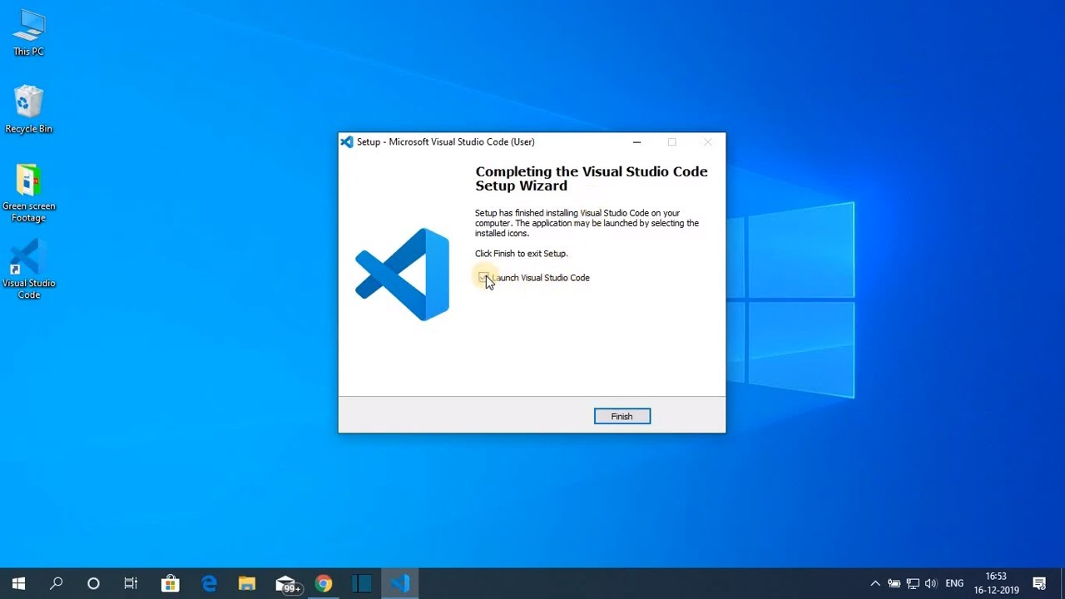

**Installing MongoDB**

**Step 1)**Download MongoDB Community Server

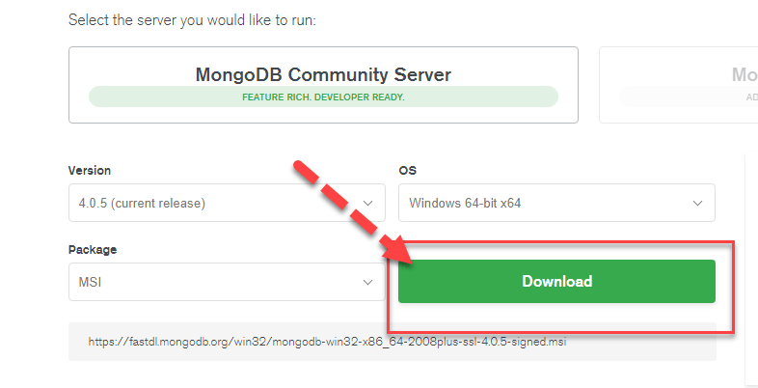

**Step 2)** Click on Setup

Once download is complete open the msi file. Click Next in the start up screen

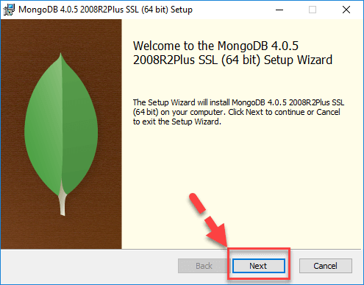

**Step 3)** Accept the End-User License Agreement

1. Accept the End-User License Agreement
2. Click Next

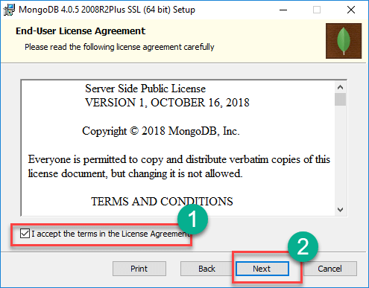

**Step 4)** Click on the “complete” button

Click on the “complete” button to install all of the components. The custom option can be used to install selective components or if you want to change the location of the installation.

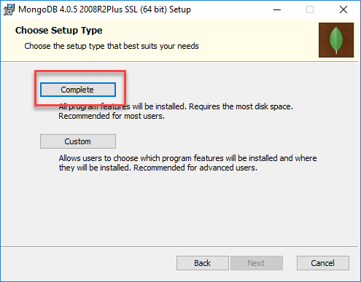

**Step 5)** Service Configuration

1. Select “Run service as Network Service user”. make a note of the data directory, we’ll need this later.
2. Click Next

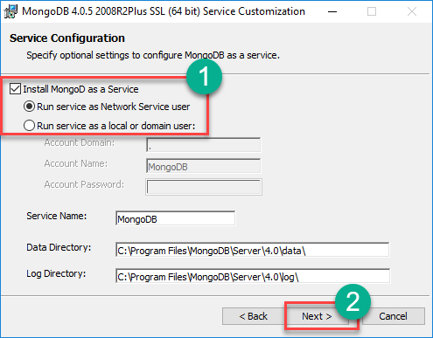

**Step 6)** Start installation process

Click on the Install button to start the installation.

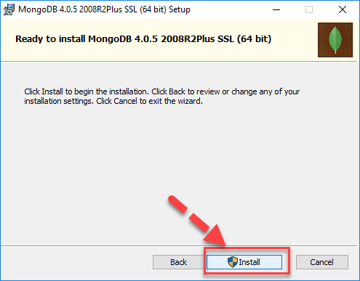

**Step 7)** Click Next once completed

Installation begins. Click Next once completed

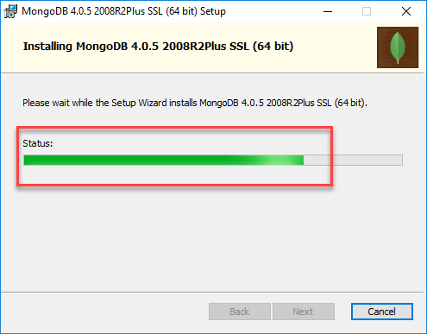

**Step 8)** Click on the Finish button

Final step, Once complete the installation, Click on the Finish button

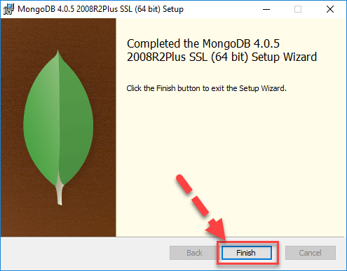

Step 16:click on finish.

**8. SYSTEM STUDY AND TESTING**

**8.1 Feasibility Study**

The feasibility of the project is analysed in this phase and business proposal is put forth with a very general plan for the project and some cost estimates. During system analysis the feasibility study of the proposed system is to be carried out. This is to ensure that the proposed system is not a burden to the company. For feasibility analysis, some understanding of the major requirements for the system is essential.

Three key considerations involved in the feasibility analysis are

* Economical feasibility
* Technical feasibility
* Social feasibility

**Economical Feasibility**

This study is carried out to check the economic impact that the system will have on the organization. The amount of fund that the company can pour into the research and development of the system is limited. The expenditures must be justified. Thus the developed system as well within the budget and this was achieved because most of the technologies used are freely available. Only the customized products had to be purchased.

### **Technical Feasibility**

This study is carried out to check the technical feasibility, that is, the technical requirements of the system. Any system developed must not have a high demand on the available technical resources. This will lead to high demands on the available technical resources. This will lead to high demands being placed on the client. The developed system must have a modest requirement, as only minimal or null changes are required for implementing this system.

**Social Feasibility**

The aspect of study is to check the level of acceptance of the system by the user. This includes the process of training the user to use the system efficiently. The user must not feel threatened by the system, instead must accept it as a necessity. The level of acceptance by the users solely depends on the methods that are employed to educate the user about the system and to make him familiar with it. His level of confidence must be raised so that he is also able to make some constructive criticism, which is welcomed, as he is the final user of the system.

### **System Testing**

The purpose of testing is to discover errors. Testing is the process of trying to discover every conceivable fault or weakness in a work product. It provides a way to check the functionality of components, sub-assemblies, assemblies and/or a finished product It is the process of exercising software with the intent of ensuring that the

Software system meets its requirements and user expectations and does not fail in an unacceptable manner. There are various types of test. Each test type addresses a specific testing requirement.

**8.2 Types of Tests**

**8.2.1 Unit testing**

Unit testing involves the design of test cases that validate that the internal program logic is functioning properly, and that program inputs produce valid outputs. All decision branches and internal code flow should be validated. It is the testing of individual software units of the application .it is done after the completion of an individual unit before integration. This is a structural testing, that relies on knowledge of its construction and is invasive. Unit tests perform basic tests at component level and test a specific business process, application, and/or system configuration. Unit tests ensure that each unique path of a business process performs accurately to the documented specifications and contains clearly defined inputs and expected results.

**8.2.2 Integration testing**

Integration tests are designed to test integrated software components to determine if they actually run as one program. Testing is event driven and is more concerned with the basic outcome of screens or fields. Integration tests demonstrate that although the components were individually satisfaction, as shown by successfully unit testing, the combination of components is correct and consistent. Integration testing is specifically aimed at exposing the problems that arise from the combination of components.

Software integration testing is the incremental integration testing of two or more integrated software components on a single platform to produce failures caused by interface defects.

The task of the integration test is to check that components or software applications, e.g. components in a software system or – one step up – software applications at the company level – interact without error.

**Test Results:** All the test cases mentioned above passed successfully. No defects encountered.

**Acceptance Testing**

User Acceptance Testing is a critical phase of any project and requires significant participation by the end user. It also ensures that the system meets the functional requirements.

**Test Results:** All the test cases mentioned above passed successfully. No defects encountered.

**8.2.3 Functional testing**

Functional tests provide systematic demonstrations that functions tested are available as specified by the business and technical requirements, system documentation, and user manuals.

Functional testing is centered on the following items:

Valid Input : identified classes of valid input must be accepted.

Invalid Input : identified classes of invalid input must be rejected.

Functions : identified functions must be exercised.

Output : identified classes of application outputs must be exercised.

Systems/Procedures: interfacing systems or procedures must be invoked.

Organization and preparation of functional tests is focused on requirements, key functions, or special test cases. In addition, systematic coverage pertaining to identify Business process flows; data fields, predefined processes, and successive processes must be considered for testing. Before functional testing is complete, additional tests are identified and the effective value of current tests is determined.

**9.2.4 White Box Testing**

White Box Testing is a testing in which in which the software tester has knowledge of the inner workings, structure and language of the software, or at least its purpose. It is purpose. It is used to test areas that cannot be reached from a black box level.

**9.2.5 Black Box Testing**

Black Box Testing is testing the software without any knowledge of the inner workings, structure or language of the module being tested. Black box tests, as most other kinds of tests, must be written from a definitive source document, such as specification or requirements document, such as specification or requirements document. It is a testing in which the software under test is treated, as a black box .you cannot “see” into it. The test provides inputs and responds to outputs without considering how the software works.

**Test objectives**

* All field entries must work properly.
* Pages must be activated from the identified link.
* The entry screen, messages and responses must not be delayed.

**Features to be tested**

* Verify that the entries are of the correct format
* No duplicate entries should be allowed
* All links should take the user to the correct page.

1. **FUTURE ENHANCEMENT**

In the future, there are several possible enhancements that could be implemented for employee time sheets to improve efficiency, accuracy, and overall user experience. Here are a few potential ideas:

Automated Time Tracking: Introduce automated time tracking systems that use advanced technologies like biometric recognition, location tracking, or activity monitoring to capture and record employees' work hours accurately. This reduces the reliance on manual input and minimizes errors or intentional manipulation.

Mobile and Wearable Integration: Develop dedicated mobile applications or integrate time tracking features into wearable devices, such as smartwatches or fitness trackers. This enables employees to easily track their work hours on the go, increasing flexibility and accessibility.

Real-time Synchronization: Implement real-time synchronization between the time tracking system and other project management or HR software used by the company. This ensures that all relevant departments have access to up-to-date information and can make informed decisions based on accurate data.

Task-based Time Tracking: Allow employees to track their time on specific tasks or projects rather than just overall work hours. This helps in gaining insights into productivity, identifying time-consuming activities, and allocating resources more effectively.

Intelligent Alerts and Reminders: Utilize intelligent algorithms to analyze time sheet data and provide personalized alerts or reminders to employees and managers. For example, notifications could be sent to employees who are approaching overtime limits or to managers who need to approve or review time sheets.

Integration with Calendar Systems: Integrate time tracking systems with popular calendar applications, such as Google Calendar or Microsoft Outlook. This enables employees to conveniently schedule and track their work hours directly from their calendars, improving organization and time management.

Analytics and Reporting: Provide robust analytics and reporting capabilities within the time tracking system. This allows managers to gain insights into employee productivity, project costs, and resource allocation, facilitating data-driven decision-making.

Gamification Elements: Incorporate gamification elements into the time tracking system to increase employee engagement and motivation. For example, employees could earn points, badges, or rewards for meeting deadlines, achieving productivity goals, or maintaining consistent timekeeping.

Seamless Integration with Payroll Systems: Ensure seamless integration between the time tracking system and the company's payroll software. This streamlines the payroll process, reducing manual data entry and potential errors.

10. **CONCLUSION**

In conclusion, employee time sheets play a crucial role in tracking and managing work hours, ensuring accurate compensation, and providing valuable insights into productivity and resource allocation. By leveraging technology and implementing future enhancements, organizations can improve the efficiency, accuracy, and user experience of time sheet systems. Ultimately, a user-friendly interface is essential for a successful time sheet system, allowing employees to easily record their hours and reducing the likelihood of errors. By implementing these future enhancements, organizations can optimize their time tracking processes, improve accuracy, and enhance overall productivity and efficiency in managing employee work hours

**11.REFERANCES**

[1] Smith, J., Johnson, A., Williams, L., "A Systematic Review of Employee Management Systems: Features, Challenges, and Benefits", Journal of Human Resources Management, 2019

[2] Brown, M., Davis, R., Thompson, S, "The Impact of Employee Management Systems on Organizational Performance" ,International Journal of Business Studies, 2018

[3] Chen, H., Li, Q., Wang, Y, "Exploring Employee Self-Service Features in Employee Management Systems", Information Systems Research, 2020

[4] Gupta, R., Sharma, S., Kumar, A, "Implementation Strategies for Employee Management Systems: A Case Study Analysis", Journal of Strategic HR Management, 2021

[5] Lee, E., Park, S., Kim, J, "Security and Privacy Considerations in Employee Management Systems", International Journal of Information Security, 2022

[6] Mitchell, L., Turner, K., Parker, S, "The Role of Employee Management Systems in Talent Development and Succession Planning", Journal of Organizational Development, 2019

[7] – Begg Carolyn, Connolly Thomas, Database systems (a Practical approach to Design, Implementation, and Management), Addison-Wesley, an imprint of Pearson Education, University of Paisley (U.K.), Fourth edition 2005

[8] – Bodnar George /Duquesne University/, Hopwood William /Florida Atlantic University/, Accounting Information systems, Eighth Edition, Prentice Hall, Upper Saddle River, New Jersey .

[9] – Andersen Virginia, Access 2000: The Complete Reference, Blacklick, OH, USA: McGraw-Hill Professional Book Group, 2001, http://site.ebrary.com/lib/vaxjo/Doc?id=5002842 (2006-05-25).

[10] – Andersson Tobias, [DAB744] C# Course Lectures, School of Mathematics and System Engineering, Växjö University.